Data Sources

Daily Price Data
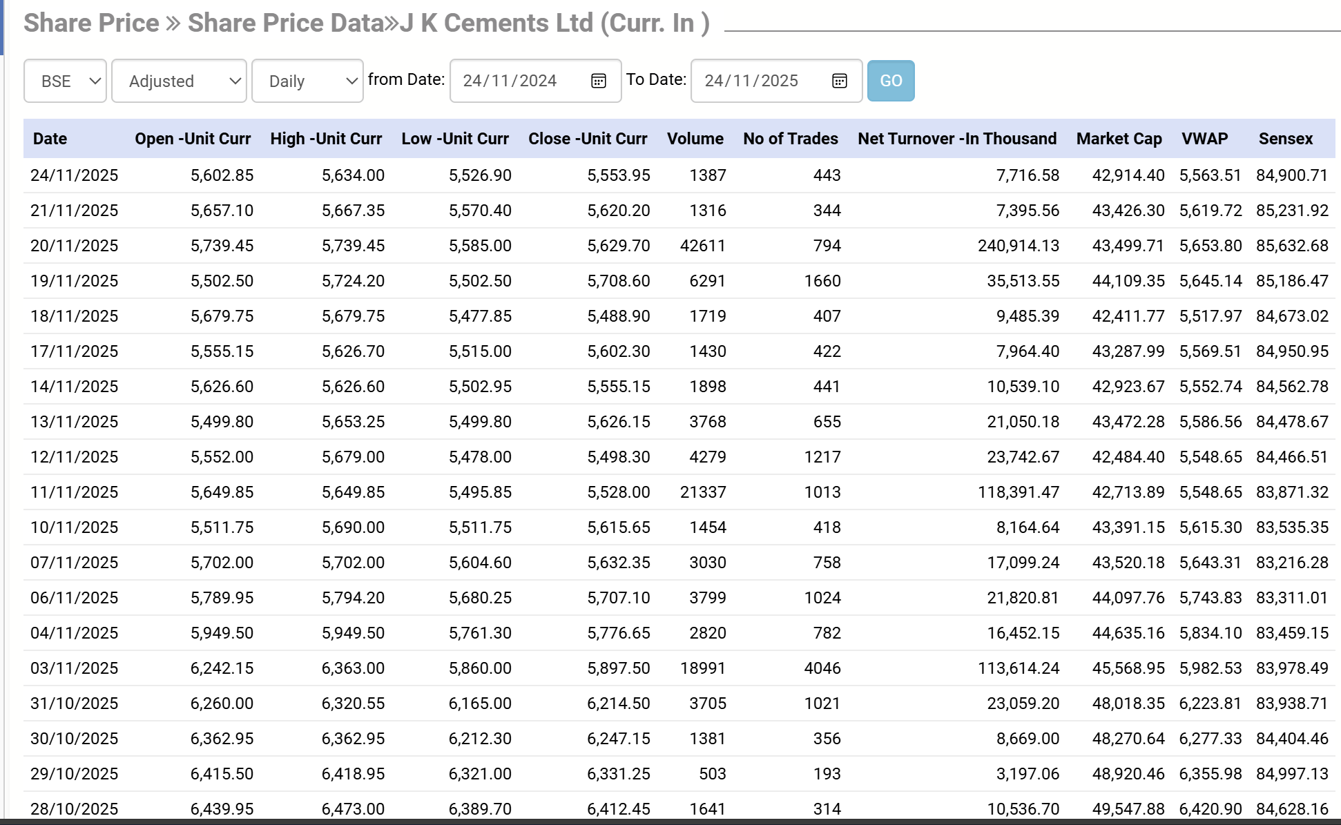

Daily Returns Data
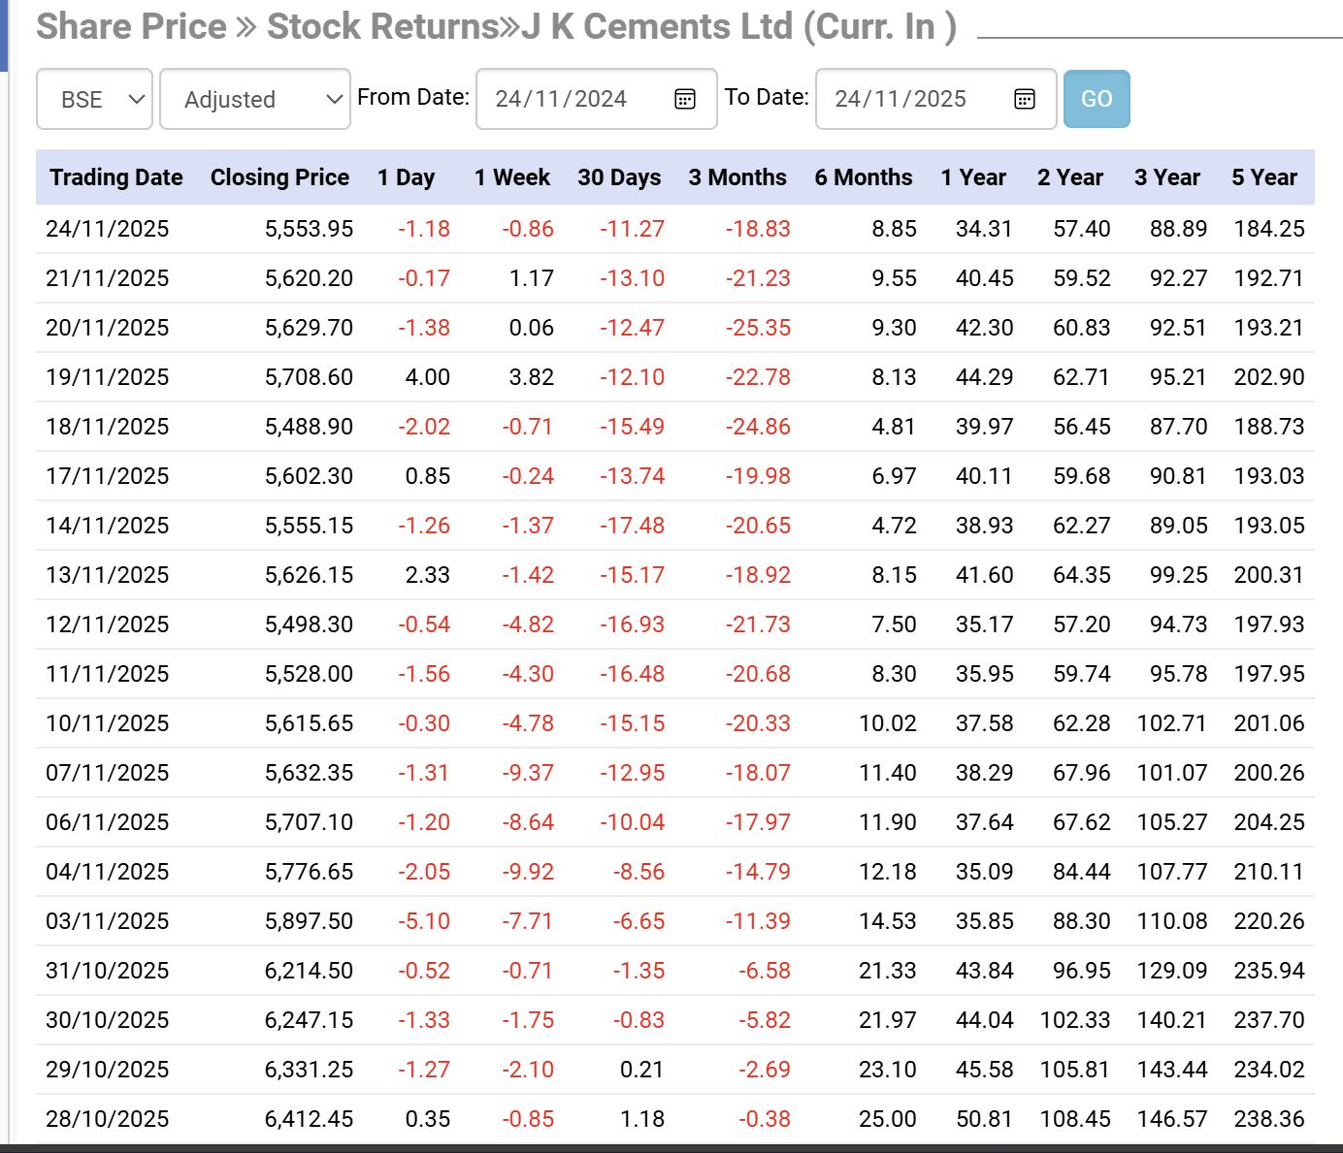

Daily Ratios Data

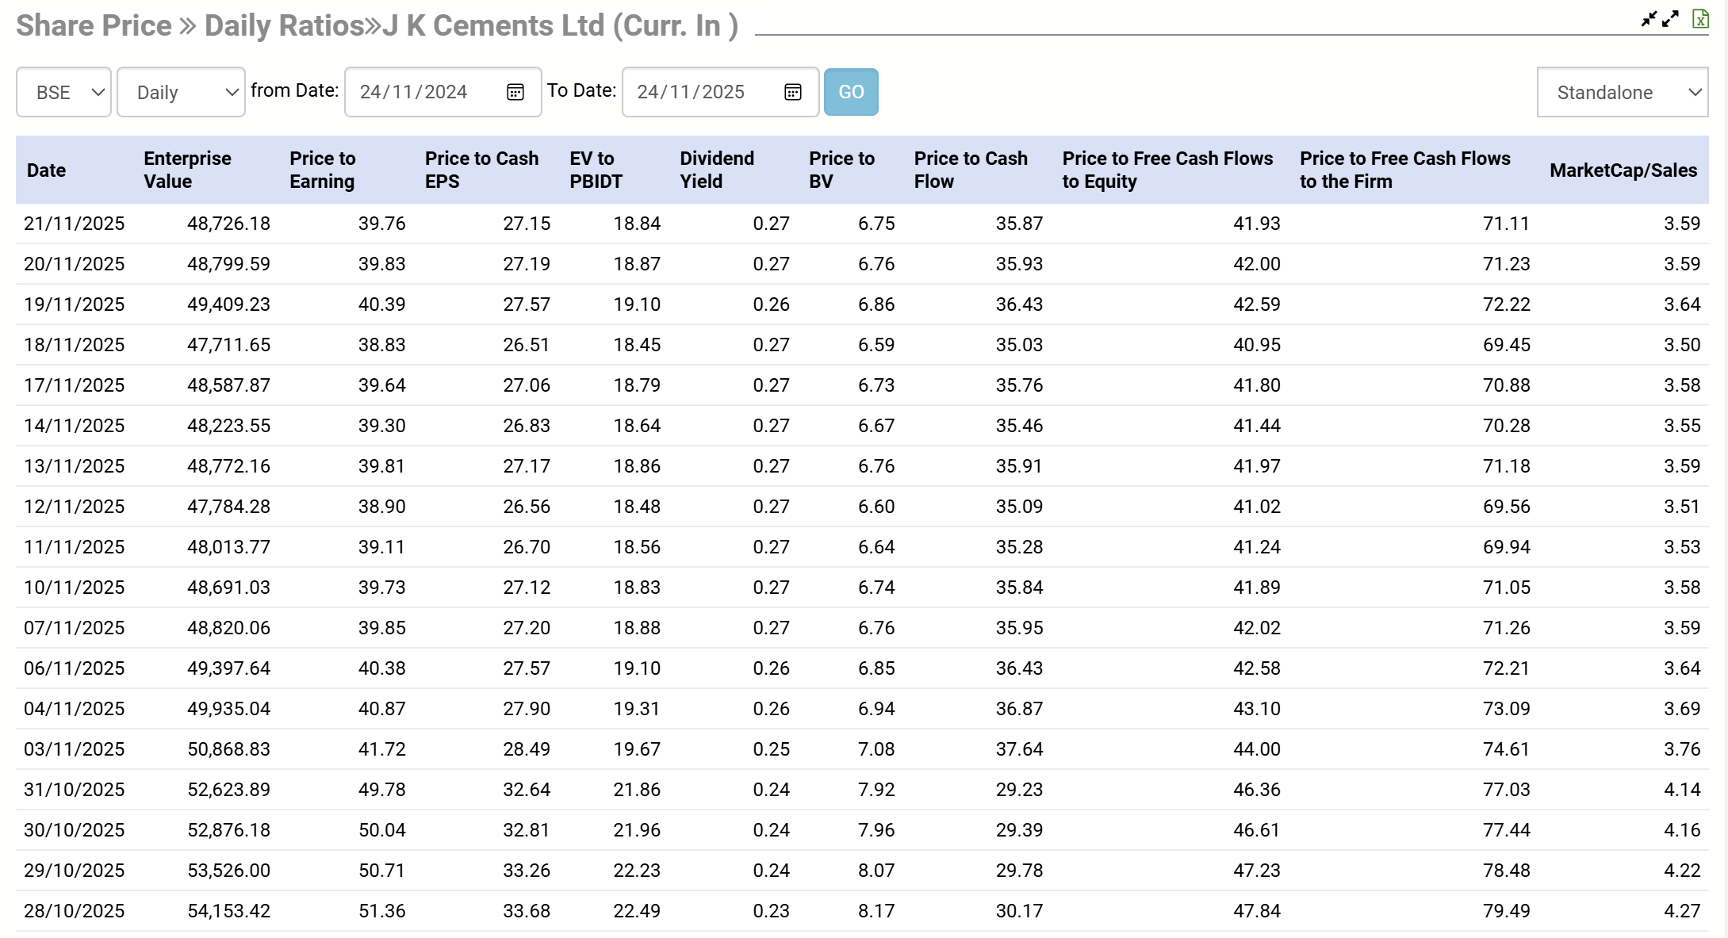

Data on Beta Values against multiple Indices
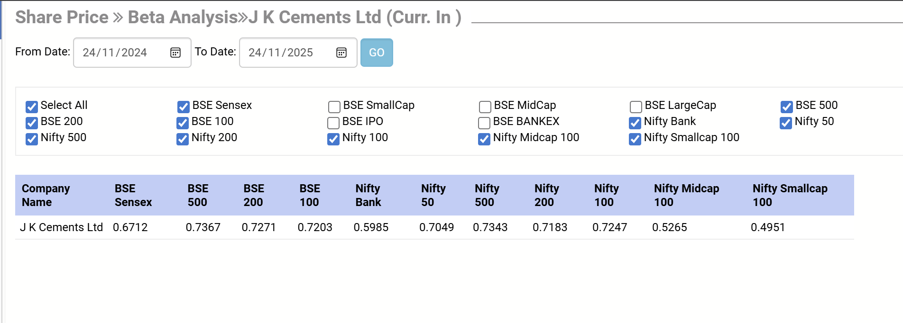

Stock Volatility Data
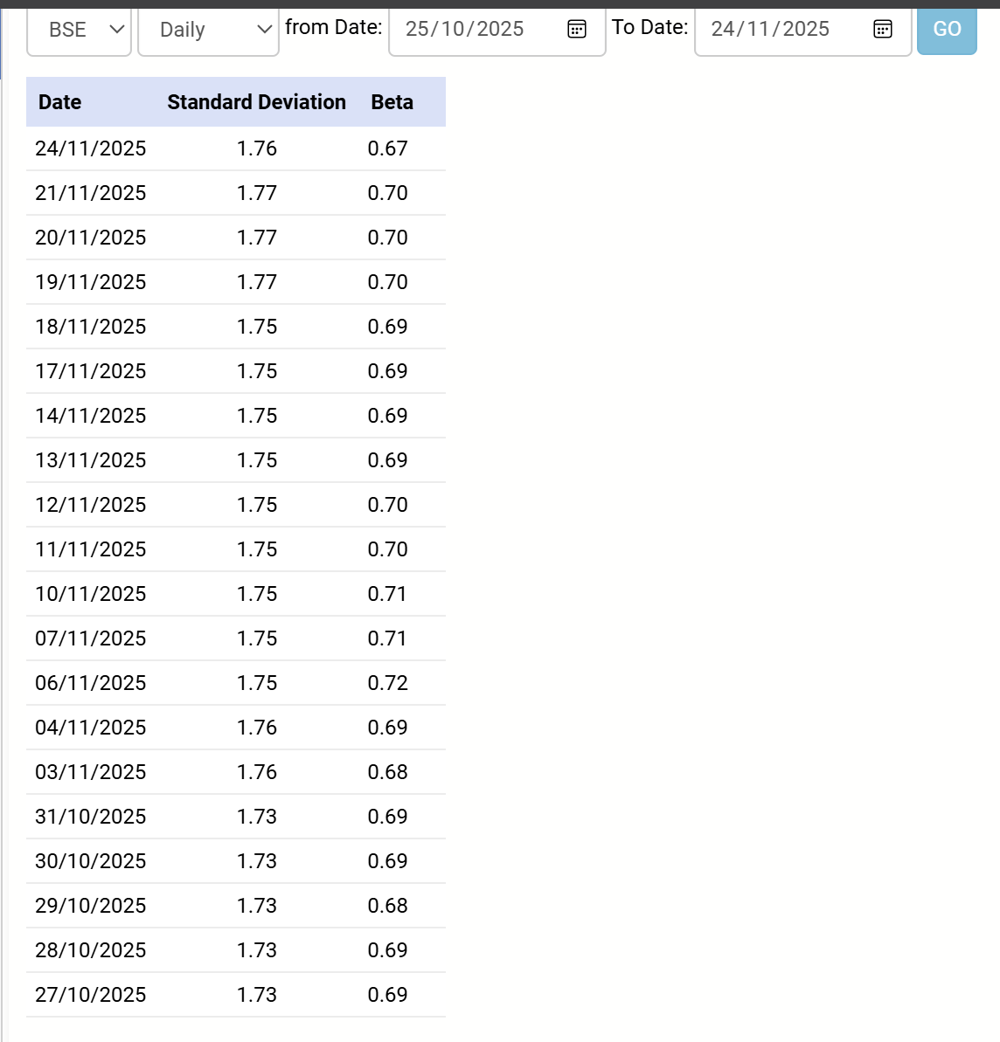

Financial Ratios of Firm, Annual
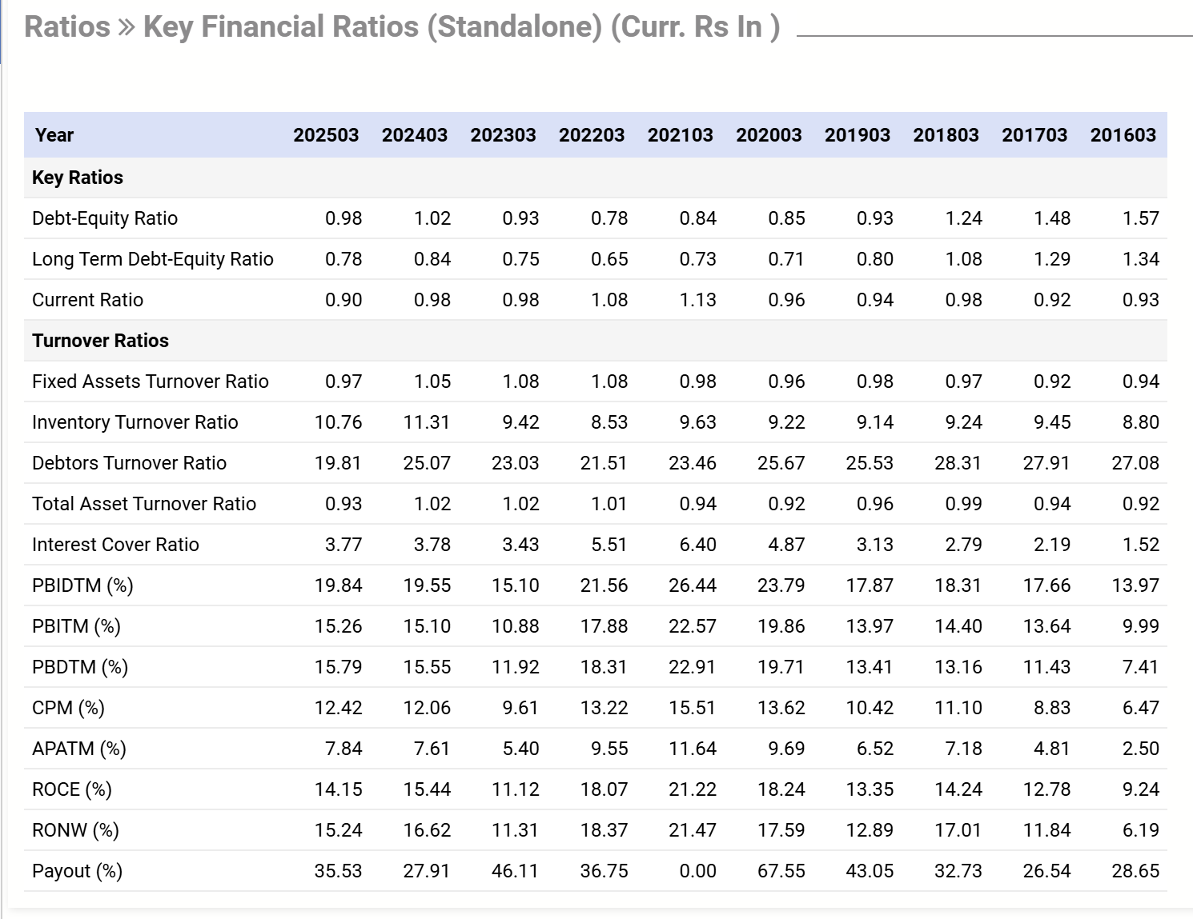

ESG scores
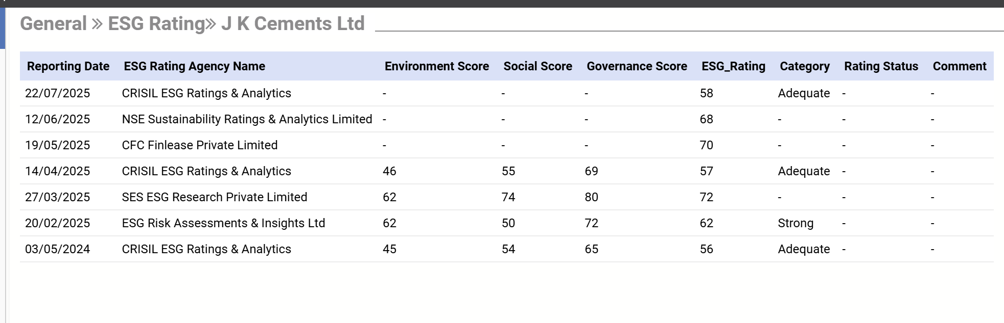

Further, Each company releases an annual sustainability report that has qualitative information.

Macroeconomic Data (eg. Inflation)
Can be obtained using EPWRF or CMIE (both available through OpenAthens using BITS Mail)
Below is monthly CPI data

